Assignment – I  
  
 Name: K MS VEERENDRA NATH

Reg No: 20BDS0203  
  
 E – Mail: [veerendranath.kms2020@vitstudent.ac.in](mailto:veerendranath.kms2020@vitstudent.ac.in)  
  
  
1) Firstly, We Have to Download Tableau Desktop & Mysql in Laptop.  
  
  
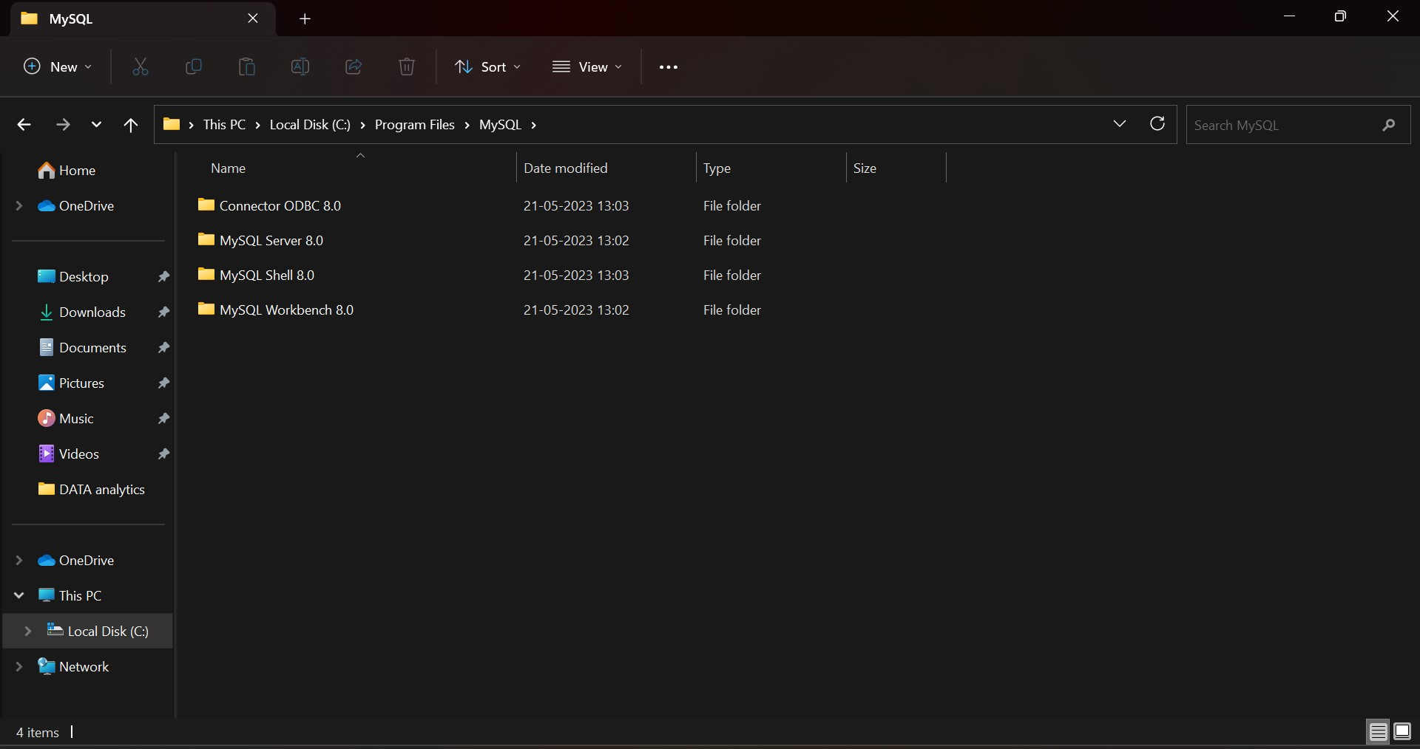  
  
  
  
  
  
  
  
  
  
  
  
  
  
  
  
  
  
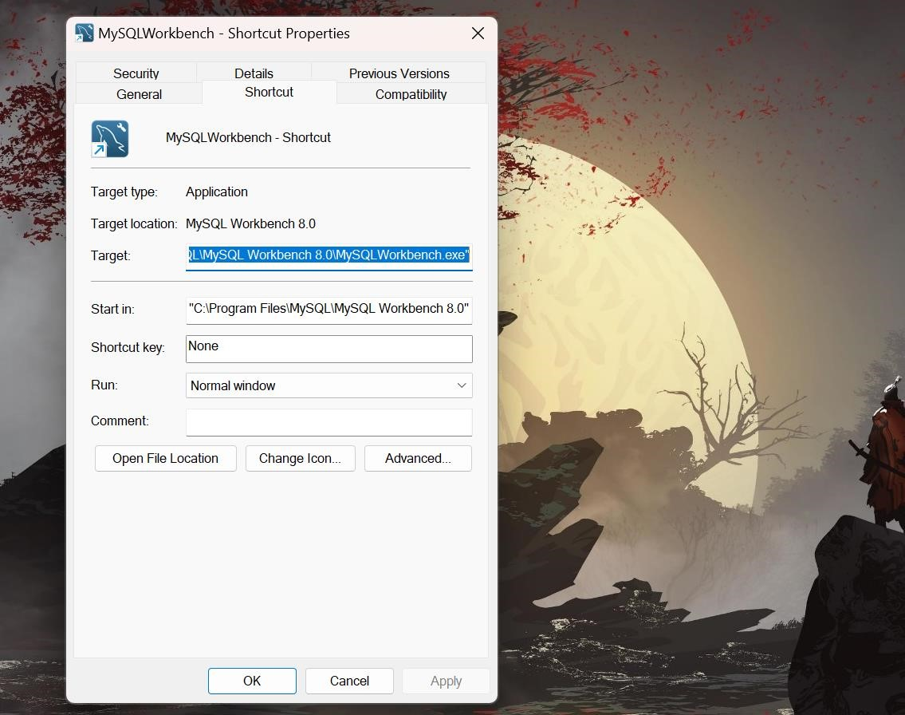   
  
  
  
  
  
  
  
  
  
  
  
  
  
  
  
  
  
  
  
  
  
  
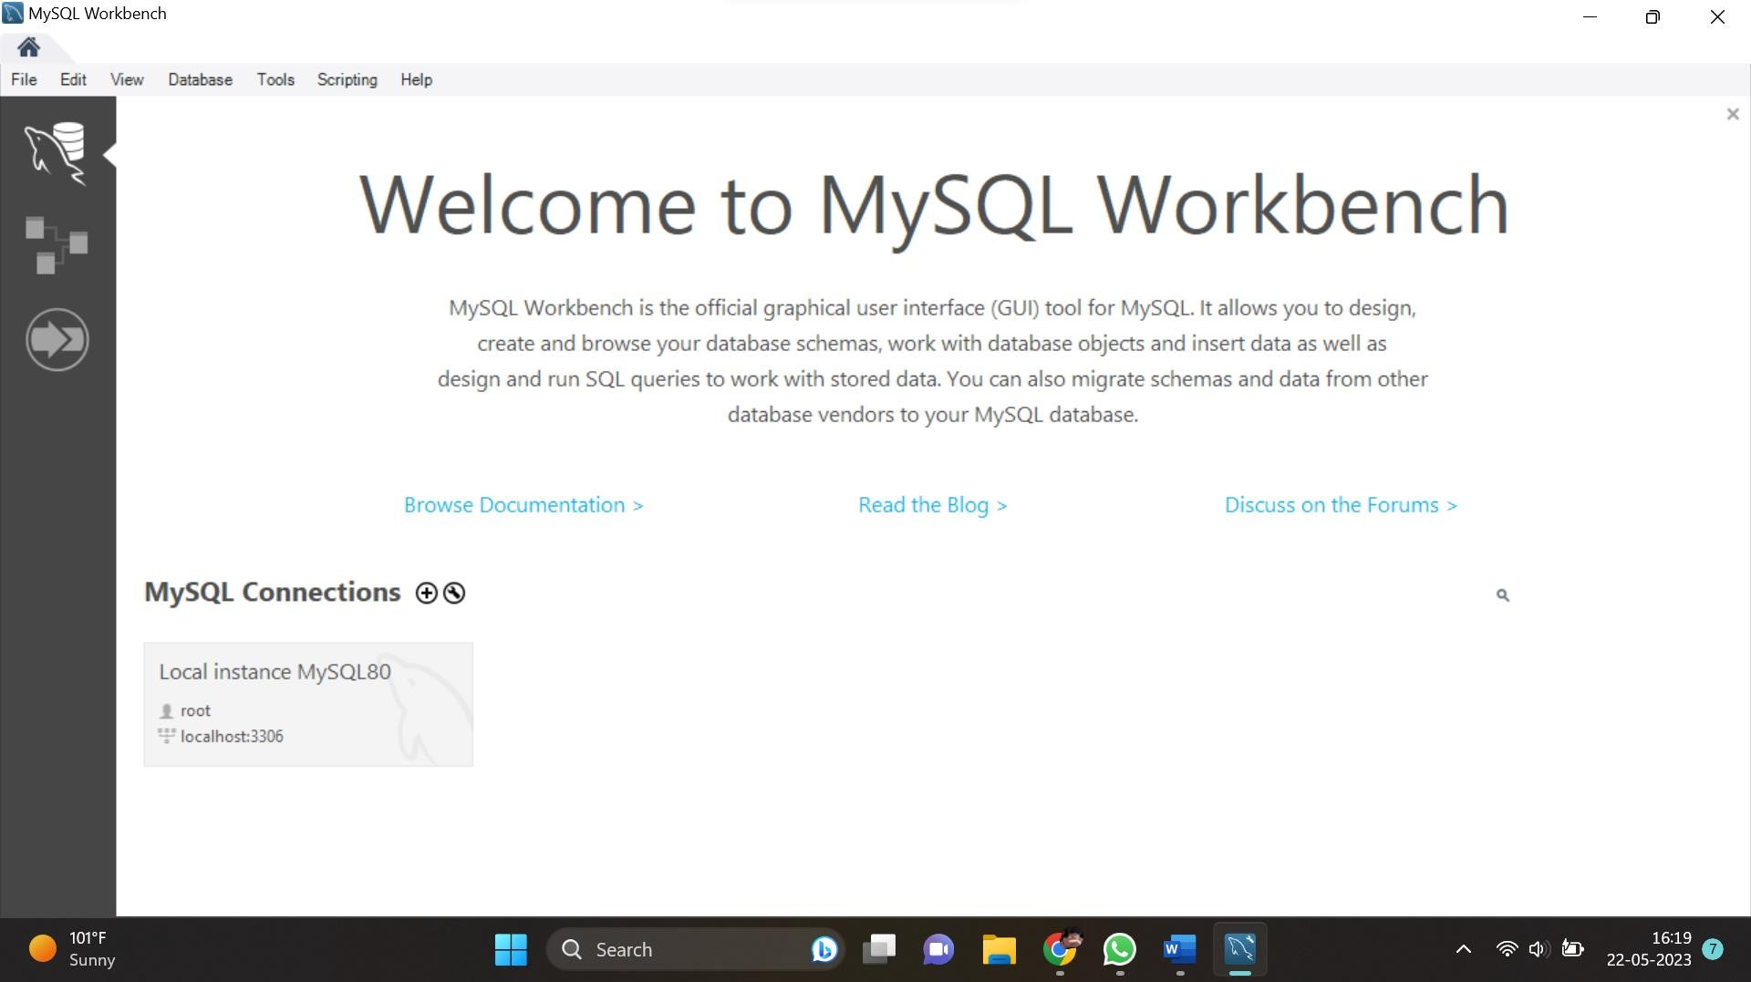

2) Create a New Schema in your Mysql workbench & Upload Your Data  
  
  
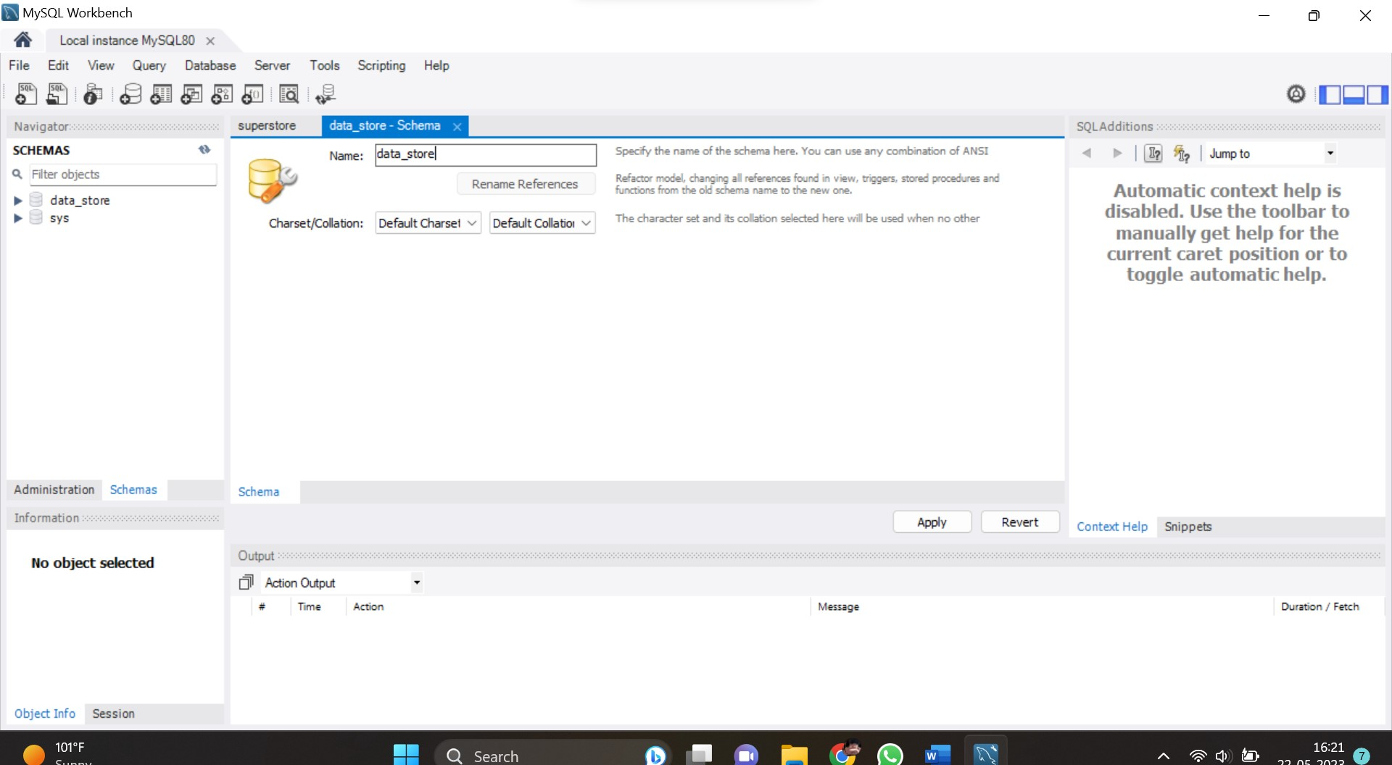

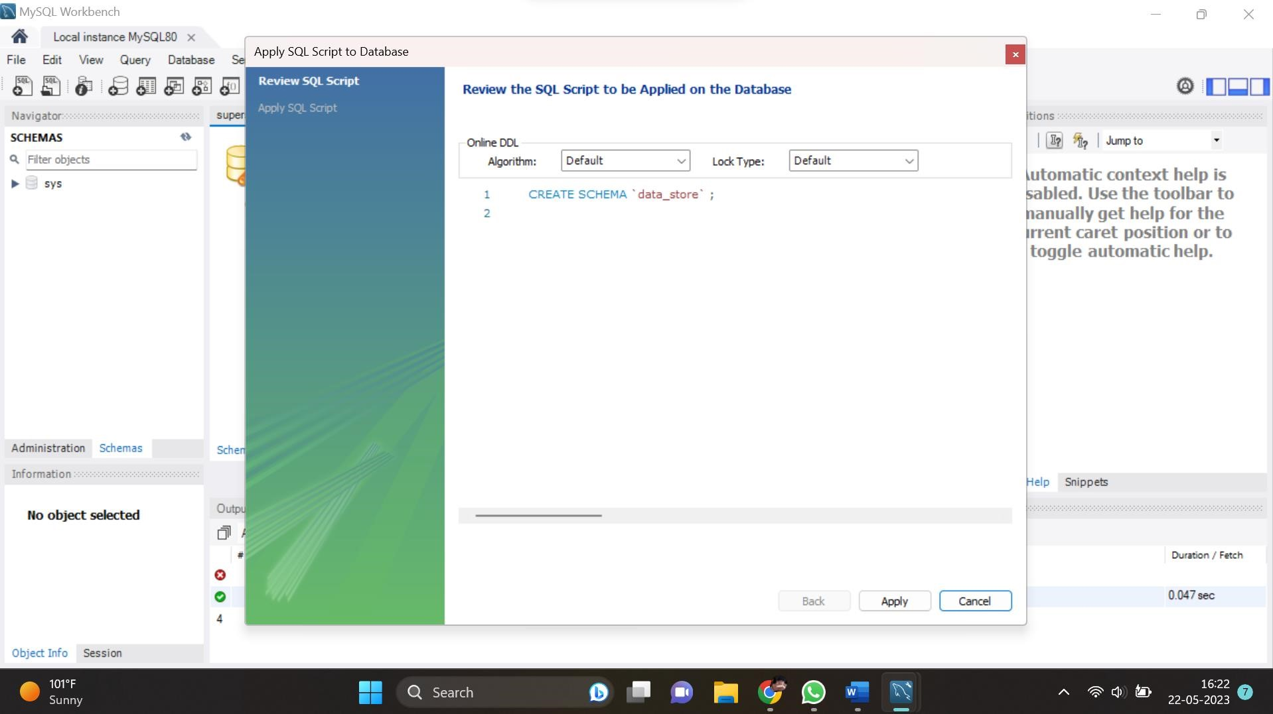

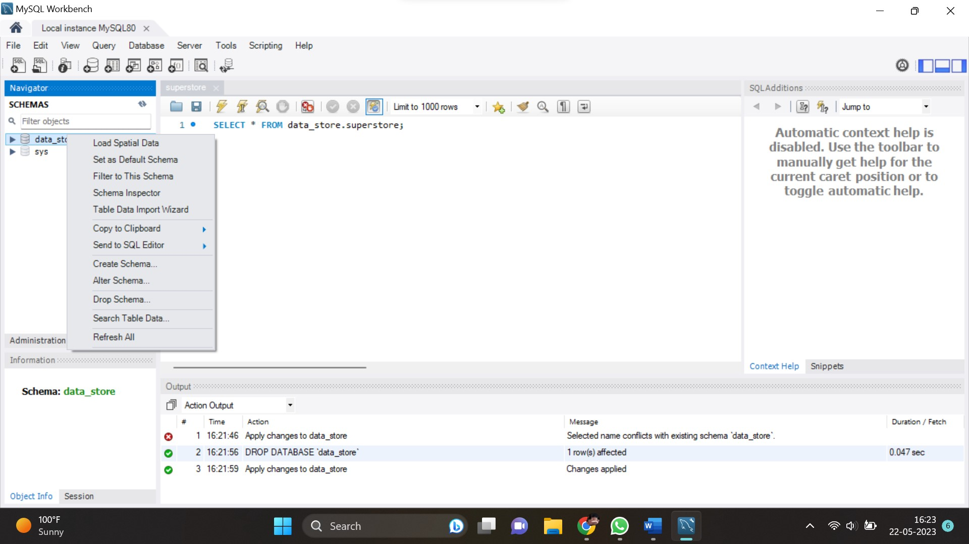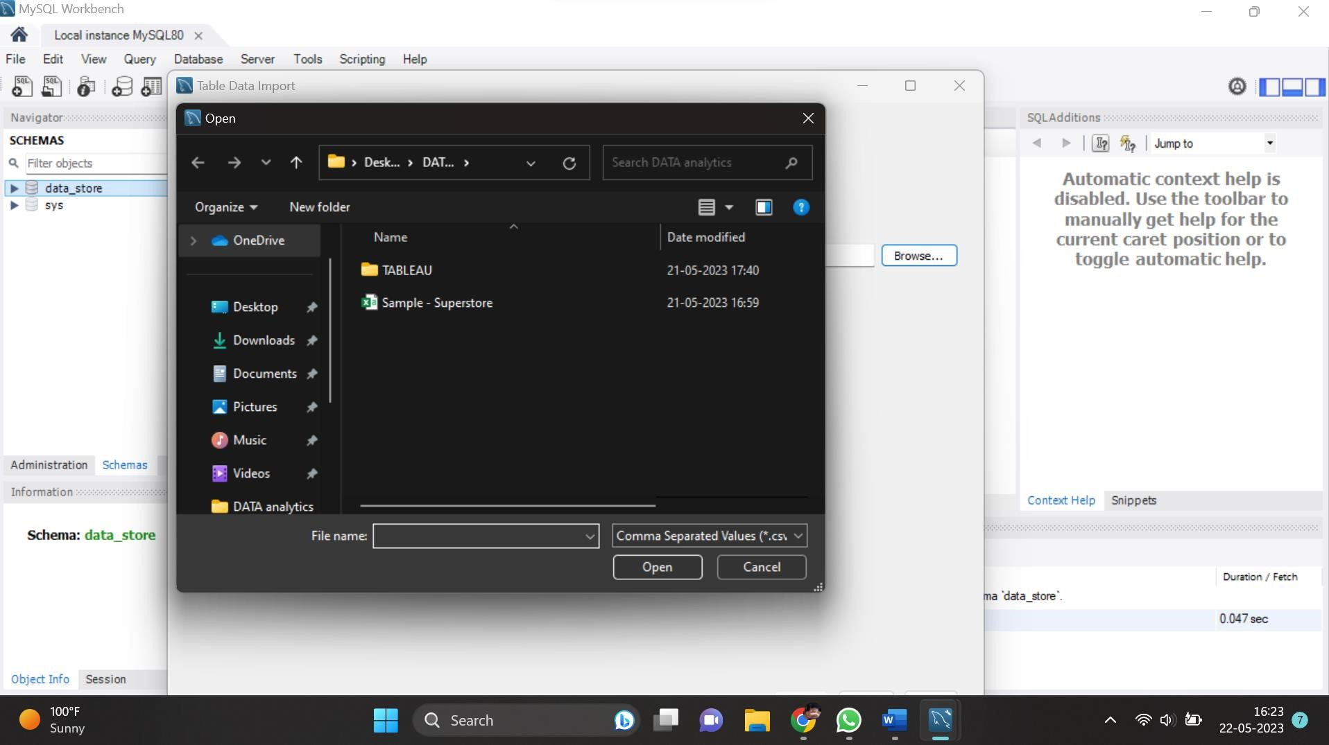

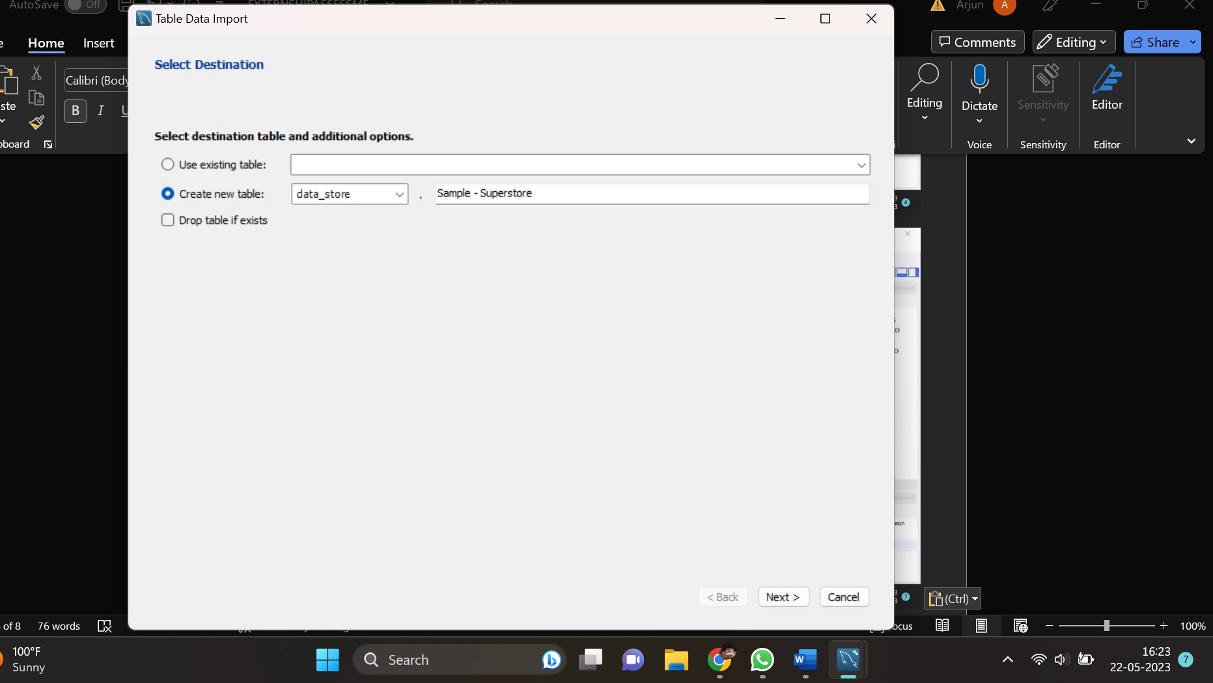

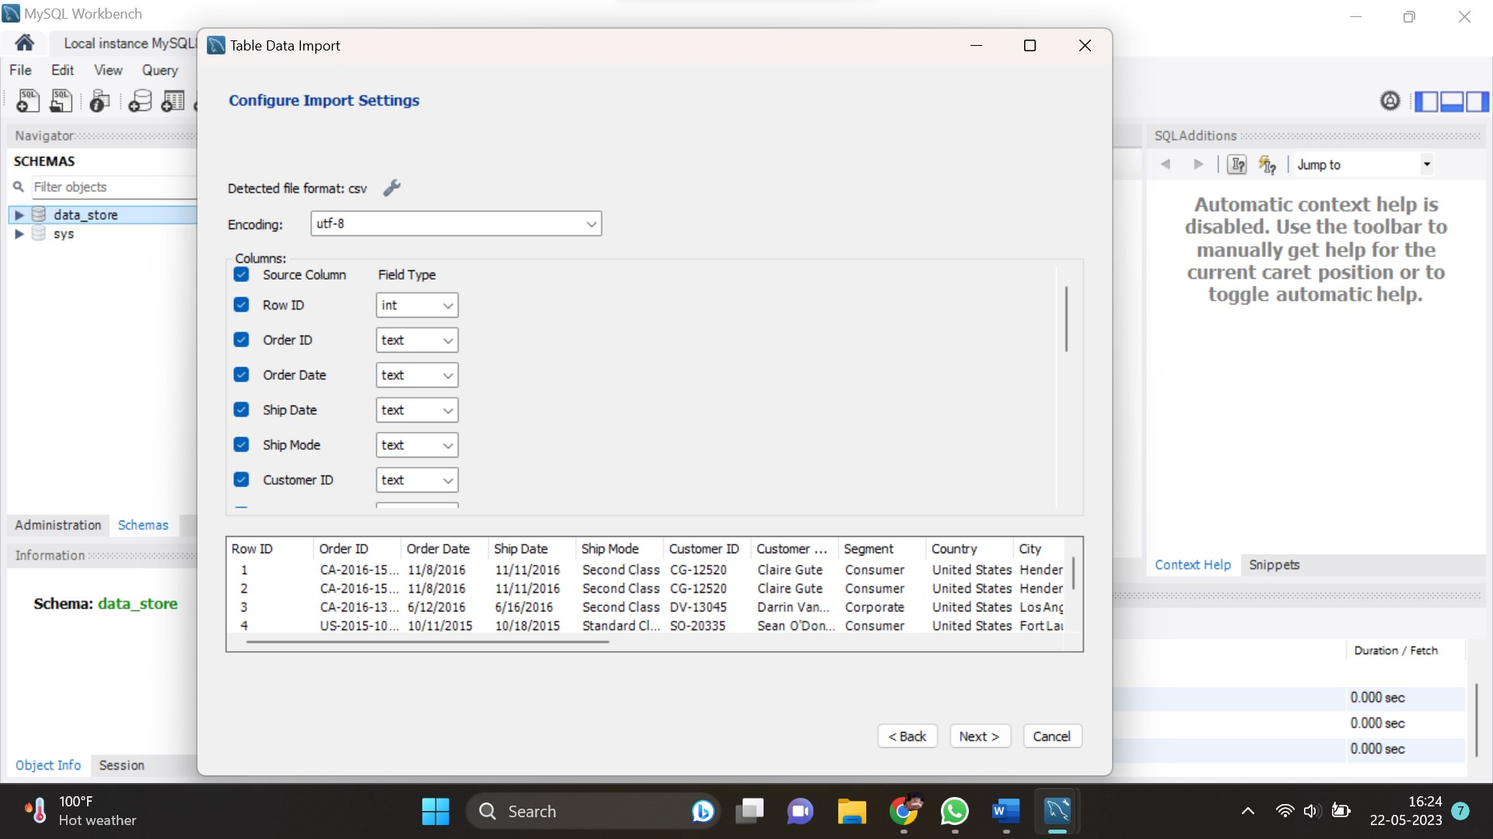

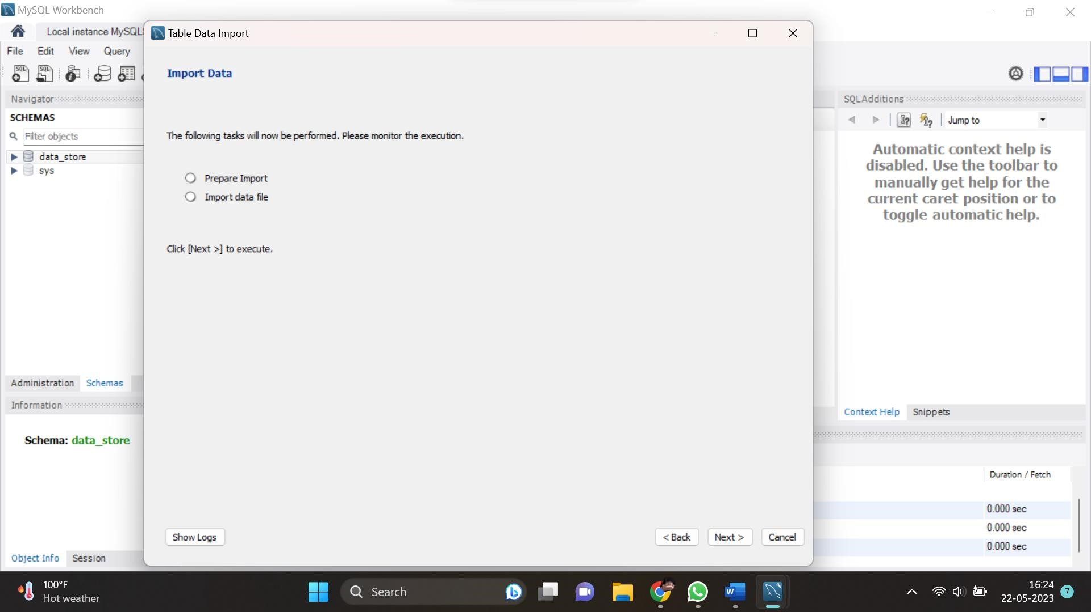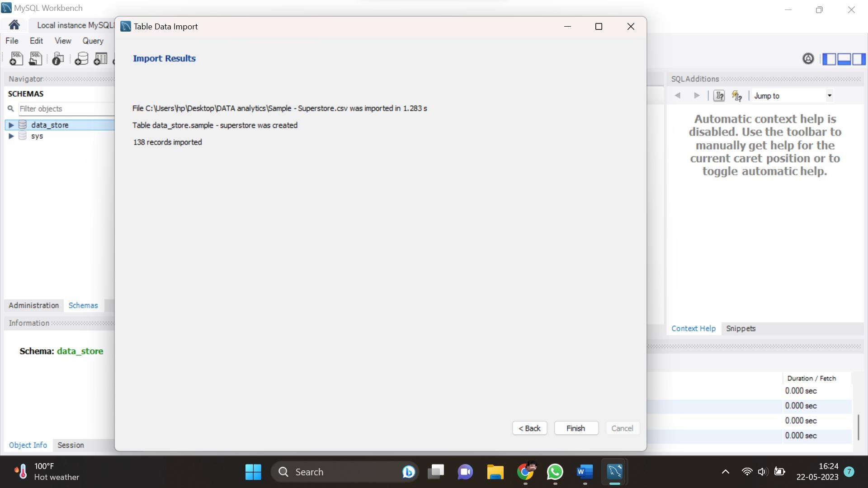

3) Connect your Mysql and Tableau

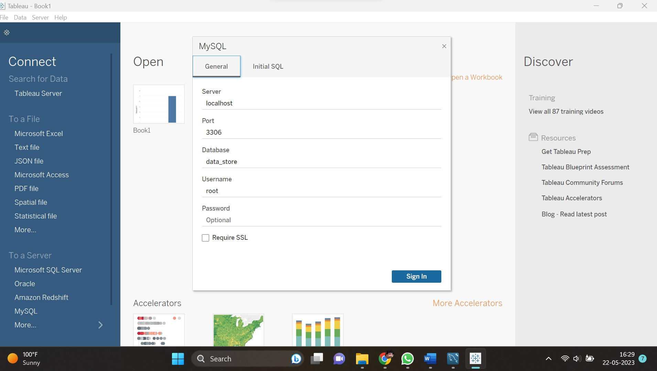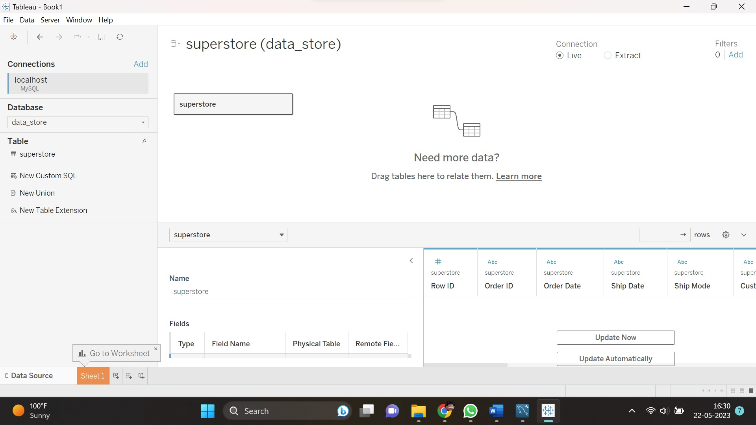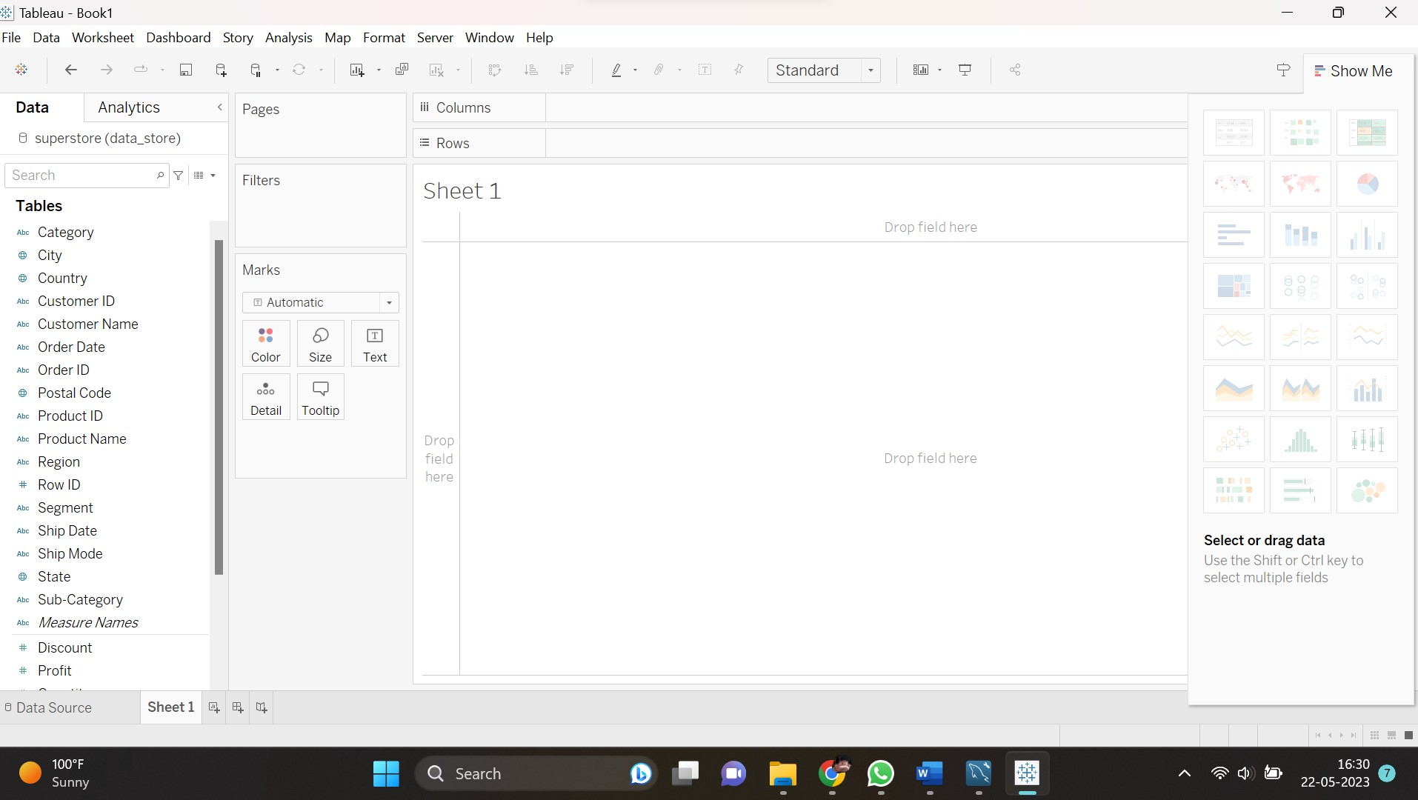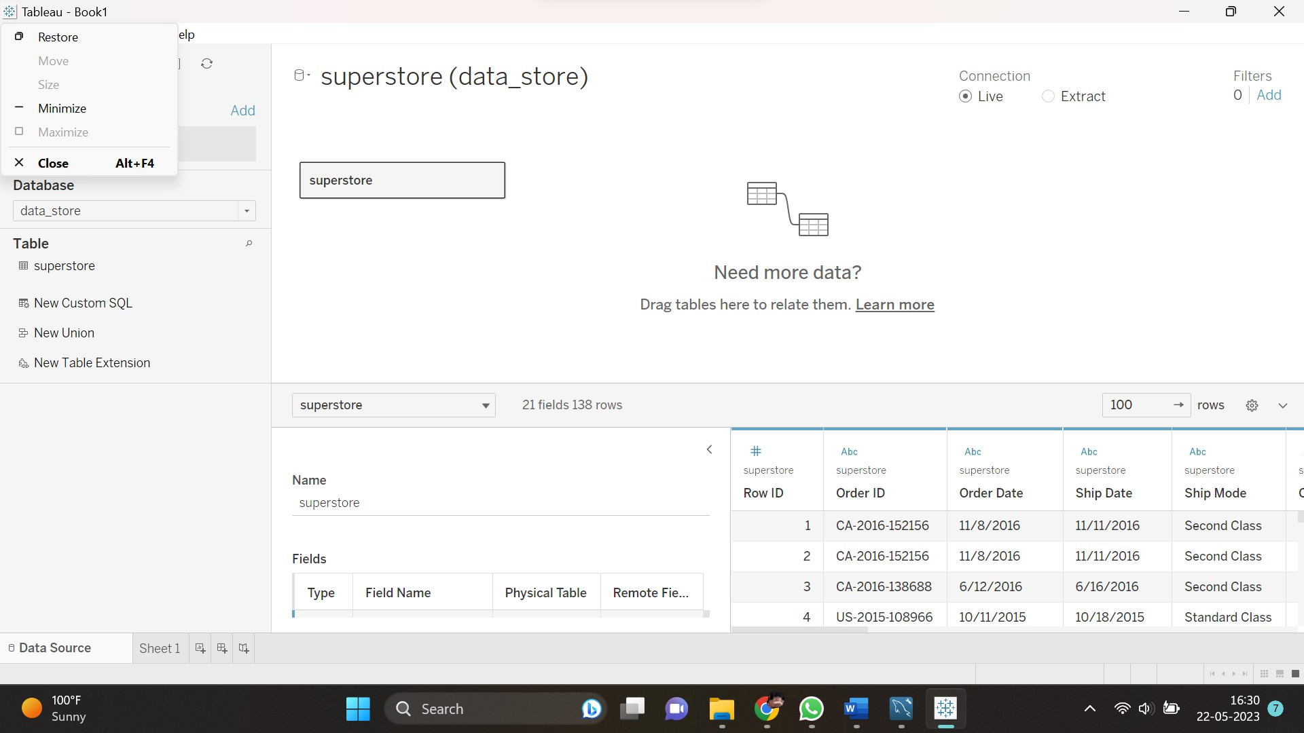

**4) Create the Below 5 Charts/ Plots**

* Bar Chart
* Tree Map
* Heat Map
* Pie Chart
* Horizontal Bar Chart  
    
    
  (i) Bar Chart:  
    
  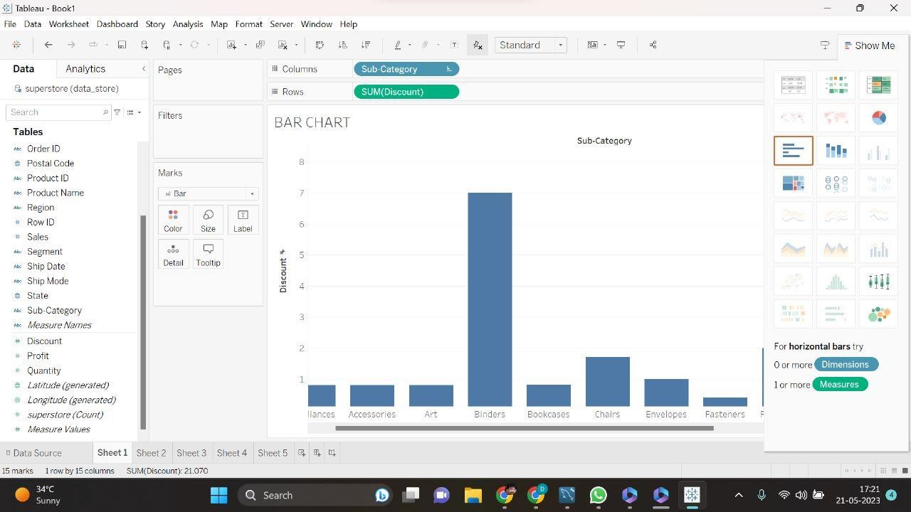  
    
    
    
    
    
    
    
    
    
  (ii) Tree Map:  
    
    
    
  (iii) Heat Map:  
    
  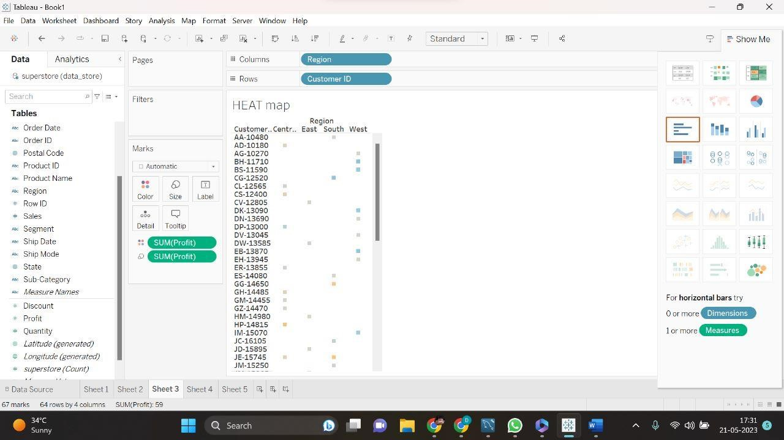  
    
    
    
    
    
    
    
  (iv) Pie Chart:  
    
  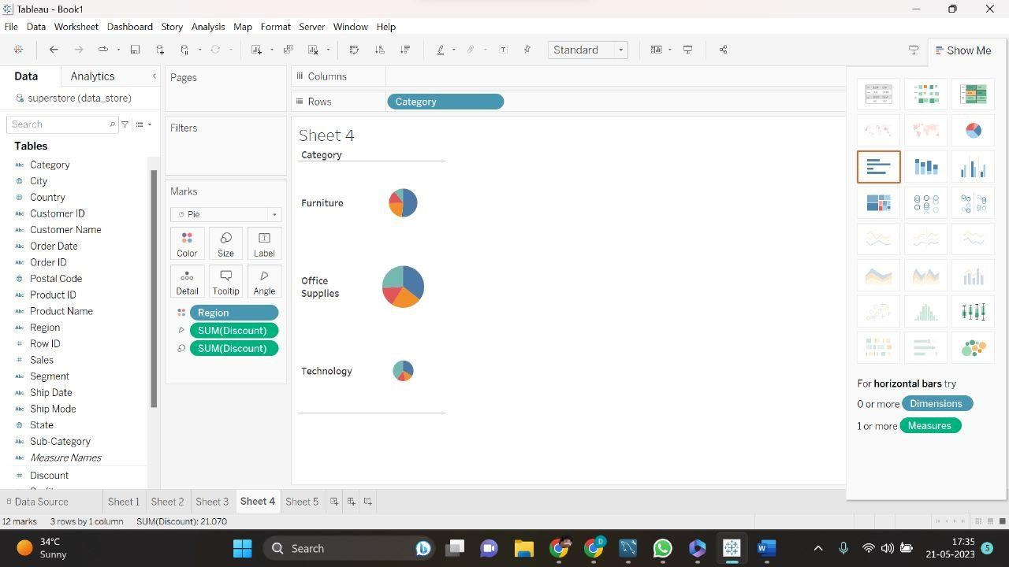  
    
  (v) Horizontal Bar Chart:  
    
    
     
   .------------------------------.